

**MINI PROJECT**

Subject Code: 20CST-472

Subject Name: Robotic Process Automation

Class Section: 20BCS-33/B

**Submitted by:**

Vivek Kumar – 21BCS8129

Vikram Sharma – 20BCS3401

**Submitted to:**

Er. Anamika Larhgotra – E15228

**Chandigarh University**

2024

**AIM-1: Design and implement a script for automating a repetitive task, with the flowchart.**

**Introduction and Theory:**

The utilization of flowcharts within UiPath represents a pivotal aspect of process automation. These visual representations elucidate complex workflows, delineating sequential steps and decision points. By integrating intuitive drag-and-drop functionality, UiPath enables users to construct comprehensive flowcharts with ease. Such flowcharts serve as blueprints for automating intricate business processes, enhancing operational efficiency, and minimizing errors. Moreover, the visual nature of flowcharts facilitates collaboration among stakeholders, fostering clarity and alignment throughout the automation journey. Through UiPath's robust platform, flowcharts emerge as indispensable tools, empowering organizations to streamline operations, optimize resource utilization, and achieve transformative outcomes in the realm of automation.

Flowcharts in UiPath serve as navigational guides, providing a visual roadmap for orchestrating automation processes. Their intuitive design interface allows for seamless creation and modification, fostering agile development cycles. By mapping out each step and decision node, flowcharts offer a comprehensive view of the automation workflow, facilitating troubleshooting and optimization. Additionally, UiPath's integration of flowcharts with its automation capabilities enables users to seamlessly translate visual diagrams into executable automation scripts. This alignment between visualization and execution streamlines the development process and enhances the scalability of automation solutions. Overall, flowcharts in UiPath represent a cornerstone of efficient and effective automation, empowering organizations to harness the full potential of robotic process automation (RPA) technology.

Creating documentation for a mini-project involving a Flowchart in UiPath involves several steps. Below is a structured approach to documenting such a project:

**1. Project Title:**

Design and implement a script for automating a repetitive task, with the flowchart.

**2. Project Overview:**

* A brief introduction to the project, including its objective and scope.

**3. Flowchart Diagram:**

* Provide a visual representation of the flowchart created in UiPath. You can use tools like Microsoft Visio or draw it manually.

**4. Process Description:**

* Describe each step of the flowchart in detail, including inputs, outputs, and any decision points.
* Use clear and concise language.
* Include screenshots from UiPath Studio if necessary to illustrate specific actions or configurations.

**5. Inputs/Outputs:**

* Document the inputs required for the process to run successfully.
* Document the expected outputs or results of the process.

**6. Variables:**

* List and describe any variables used in the project.
* Include the variable type, purpose, and value if applicable.

**7. Activities:**

* Document each activity used in the flowchart.
* Include a brief description of its purpose and how it contributes to the overall process.
* Mention any specific settings or configurations for each activity.

**8. Decision Points:**

* Identify any decision points within the flowchart.
* Document the conditions that lead to each decision and the subsequent actions.

**9. Error Handling:**

* Describe how errors or exceptions are handled within the process.
* Document any try-catch blocks, error handling activities, or retry mechanisms implemented.

**10. Testing:**

* Document any testing procedures performed on the process.
* Include test cases, expected outcomes, and actual results.

**Steps of Implementation:**

Step 1. Open the UI Path Studio

Step 2. Go to Activity bar and Select the Flow Chart

Step 3. Drag the Assign Activity and Add below Start in flow Chart

Step 4. Click Crtl+K to create the Variable name as randomNumber and use the Random() function to generate the random number

Step 5. Add WriteLine Activity and Print the Random Number in the Output console

Step 6. Add the Input Dialog and take the integer input and save in the Variable

Step 7. Add the Comparison Decision from the Activity bar and Compare the Random Number and the input number.

**If the number matches then (True):**

Step 8. Add the message box and print the number matches.

Step 9. Add another input dialog to take the RePlay Decision input.

Step 10. If the RePlay decision is the **True** then Go-To Assign Activity to Generate the Another Random number based on step-4.

Step 11. If the RePlay decision is the **False** then Go-To Message box Activity which close the program with Thank You message.

**If the number doesn’t match then (False):**

Step 12. Add Message box to display the number doesn’t match massage.

Step 13. Add another input dialog to accept the what to continue design as ‘Y’

Step 14. Add Restart Decision for the comparison and

Step 15. If the Decision is the **True** the Go-To the Input Activity based on step-6.

Step 16. If the Decision is **False**  then Go-To the message box to Close the program with the Thank You message.

**Output With All Steps:**

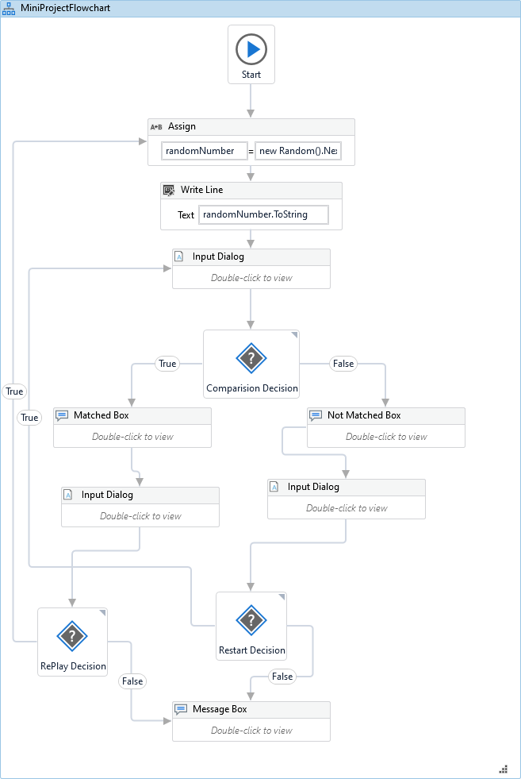

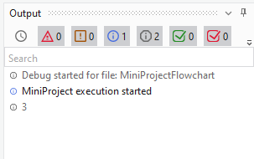

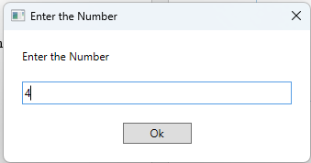

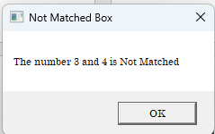

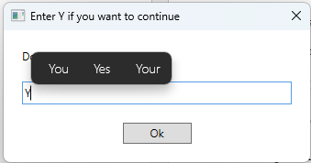

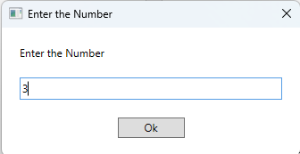

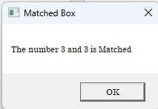

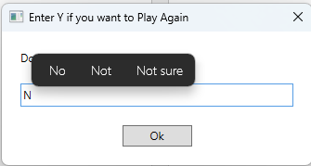

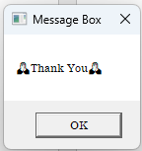

**Conclusion:**

In conclusion, the UiPath flowchart proves invaluable for process automation, streamlining workflows, and enhancing productivity. Its visual representation clarifies sequences, identifies bottlenecks, and optimizes tasks. Successful implementation yields time savings and improved accuracy. Continuous testing and refinement ensure sustained performance and reliability. Stakeholder feedback drives iterative improvements, aligning automation with evolving needs. The flowchart empowers organizations to achieve greater efficiency, cost-effectiveness, and scalability. Its utilization underscores UiPath's pivotal role in revolutionizing business operations through intuitive automation solutions.

**AIM-2: Design and implement a Data Scraping technique and demonstrate the uses.**

**Introduction and Theory:**

In the era of big data, extracting valuable information from various sources on the internet has become crucial for businesses, researchers, and analysts. Data scraping is a technique used to extract structured data from websites and web pages. It automates the process of gathering data, enabling users to collect large volumes of information efficiently and effectively.

**Theory of Data Scraping**

Data scraping involves extracting specific information from HTML pages or other structured data formats such as JSON or XML. Here's a breakdown of the key components and processes involved in data scraping:

**HTML Parsing:** HTML (Hypertext Markup Language) is the standard language used to create web pages. Data scraping tools parse the HTML code of web pages to identify and extract desired information. HTML parsing involves analyzing the structure of the HTML document, identifying relevant tags and attributes, and extracting data accordingly.

**XPath or CSS Selectors:** XPath (XML Path Language) and CSS (Cascading Style Sheets) selectors are used to locate specific elements within an HTML document. XPath is particularly useful for navigating XML documents, while CSS selectors are commonly used for selecting elements in HTML documents. Data scraping tools leverage XPath or CSS selectors to target and extract specific data elements such as text, links, images, tables, and more.

**Regular Expressions:** Regular expressions (regex) are patterns used to match and extract specific strings of text within a larger document. Data scraping tools may utilize regular expressions to extract data that follows a certain pattern or format, such as phone numbers, email addresses, dates, and more.

**HTTP Requests**: Data scraping involves sending HTTP requests to web servers to retrieve web pages and their associated content. Data scraping tools can simulate web browsers by sending GET or POST requests to fetch HTML documents. They may also handle cookies, headers, and other parameters to mimic human-like browsing behavior.

**Data Extraction and Transformation**: Once the relevant data is identified within the HTML document, data scraping tools extract and transform it into a structured format such as CSV, JSON, or Excel. This may involve cleaning and formatting the data to ensure consistency and usability.

**Pagination and Pagination Handling**: In cases where data is spread across multiple pages, data scraping tools must handle pagination to retrieve all relevant data. This may involve navigating through multiple pages, following pagination links, and aggregating data from each page into a single dataset.

Overall, data scraping is a powerful technique for extracting valuable insights and information from the vast expanse of the internet. It empowers users to automate the process of data collection, enabling them to gather, analyze, and leverage data for various purposes such as market research, competitive analysis, lead generation, and more.

**Steps of Implementation:**

Step 1. Open the UI Path Studio

Step 2. Go-To Activity bar and select the Use Application/Browser

Step 3. Go-To menu bar and select the Table Extraction option for the Data Scrapping.

Step 4. Select the Appropriate option such as Add table on the website table data.

Step 5. Select the prompt as I need to extract All columns and hit enter.

Step 6. When all data is extracted then click on the next button to select the next action of the Table Extraction

Step 7. Click on the Save option for the Save the activity.

Step 8. Accept the prompt for multiple page and row.

Step 9. Add the Write Range activity to store the each and every data extracted from the website to the Excel Sheet.

**Output:**

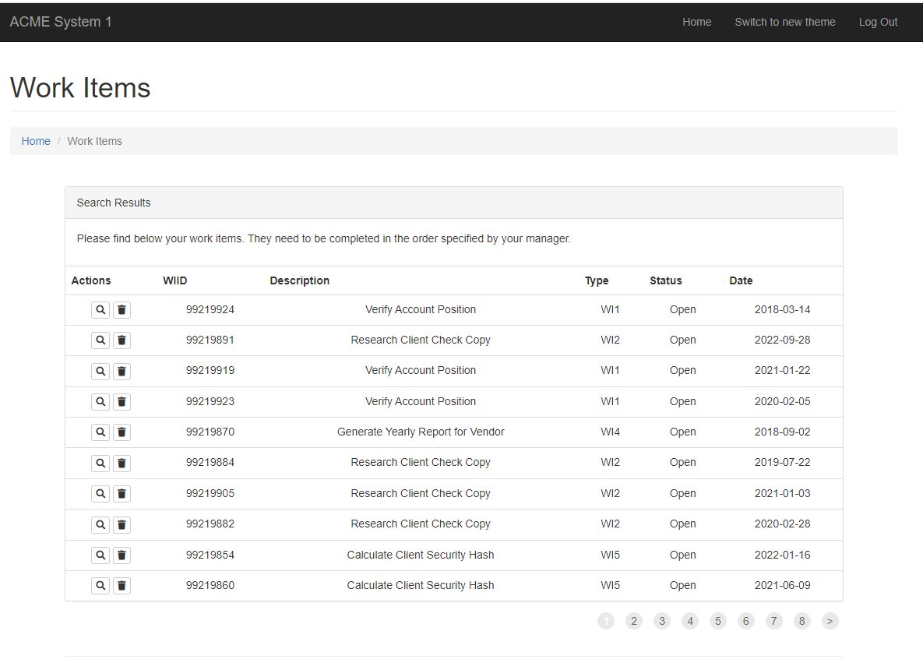

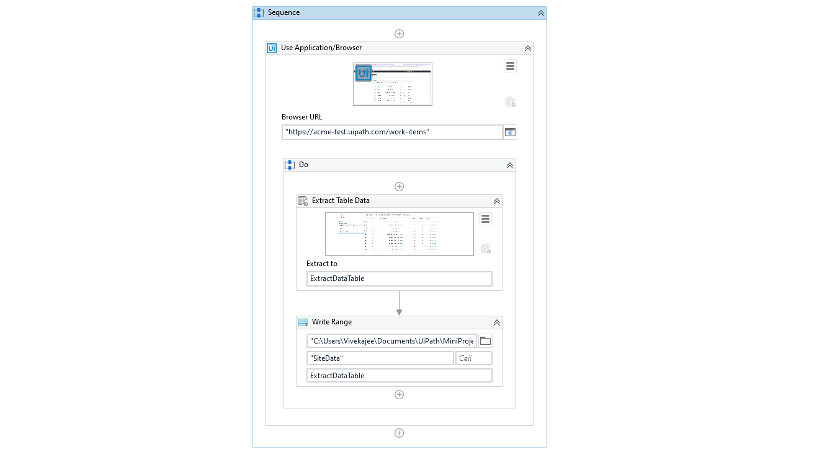

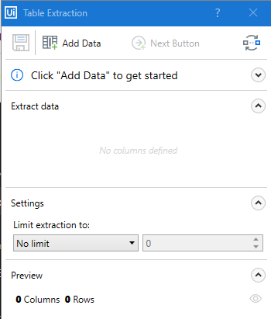

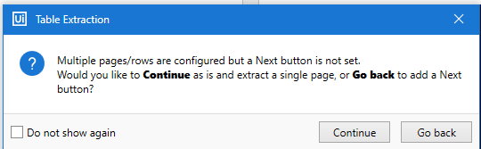

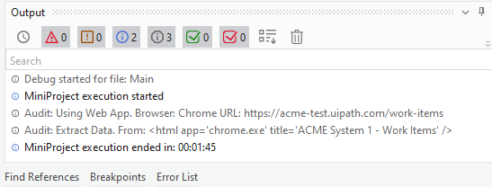

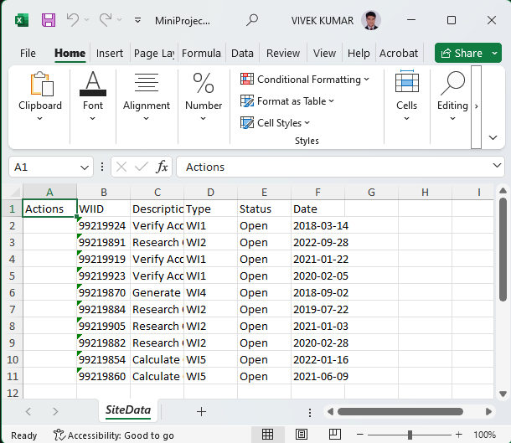

**Conclusion:**

In summary, data scraping emerges as an indispensable technique for extracting valuable insights from the vast digital landscape. Its ability to parse HTML, leverage XPath/CSS selectors, and employ regular expressions facilitates efficient data extraction. Through HTTP requests and pagination handling, it retrieves and transforms diverse data into structured formats. Data scraping streamlines processes, enhances decision-making, and empowers businesses, researchers, and analysts alike. Continuous refinement ensures accuracy and relevance, while stakeholder feedback drives iterative improvements. With its pivotal role in unlocking actionable intelligence, data scraping stands as a cornerstone in leveraging the wealth of information available online for strategic advantage and informed decision-making.